From: biodiversity@charnwood.gov.uk <biodiversity@charnwood.gov.uk>
Sent: Wednesday, February 15, 2023 4:18 PM
To: Liam Ward <Liam.Ward@charnwood.gov.uk>
Cc: development.control@charnwood.gov.uk
Subject: RE: P20-3155 P/21/2639/2 - Land North of Barkby Road, Syston

As this is an outline application and that I’ve said in previous comments that the baseline is acceptable we should (if permission is granted) seek to control the provision of ecological mitigation via an S106, in the event that offsite mitigation is required

It would be helpful to try and cover the ecological report recommendations with conditions:
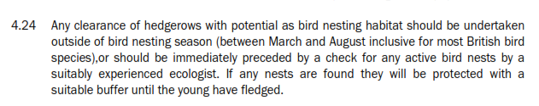

I think this would be best dealt with as part of a CEMP- EG use a general CEMP condition but mention biodiversity / CS13 in the reason

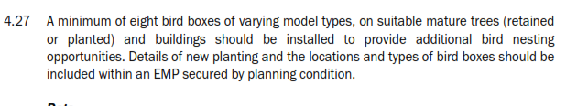
Separate -precommencement condition to cover bat and bird features- we’ll need to approve a plan showing details
4.30 below would be covered by a tree protection plan and precommencement requirement for a lighting plan – mentioning biodiversity in the reason

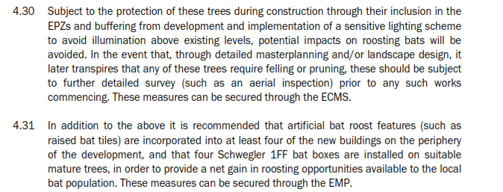

Maybe also reference CS13/biodiversity in the landscaping/ landscape management conditions

Hope this is useful
Rupert

