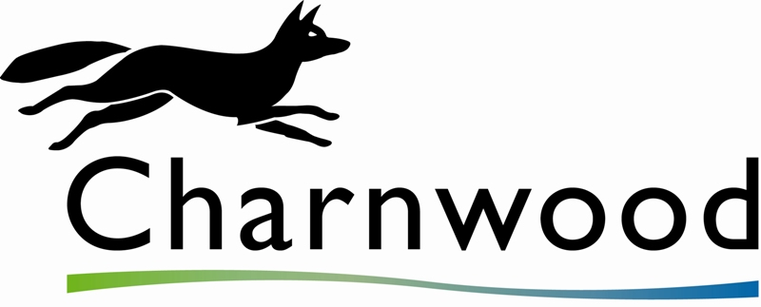 | Business Checklist for the Food Hygiene Rating Scheme
Food Safety Management System
Do you have a documented Food Safety Management System?  For small businesses we recommend Safer Food Better Business pack. The pack is FREE and is available by telephoning 0845 606 0667, alternatively you can download a copy from www.food.gov.uk  If you do not quite understand what is required for your business, please contact Charnwood Borough Council , Commercial Section | Y | N
Do you record your monitoring checks?  (Safer Food, Better Business diary or your own temperature record sheets) | Y | N
Food Handling Practices and Cleaning
Do you have a wash hand basin that is easy for food handlers to get to? | Y | N
Do wash hand basins have hot water, soap and do you have something hygienic to dry hands with? | Y | N
Do you and your staff follow good personal hygiene, including frequent hand washing? | Y | N
Do your staff tell you if they are suffering from sickness and / or diarrhoea? | Y | N
Do you and your staff use clean protective over-clothing? | Y | N
Do you have controls in place to prevent cross-contamination occurring during delivery, storage, preparation, cooking and service? | Y | N
Do you and your staff clean as you go? | Y | N
Are work surfaces and equipment kept clean and sanitised/disinfected? | Y | N
Are the hand contact surfaces, such as taps, door, drawer and fridge handles and light switches clean? | Y | N
Are floors, walls and ceilings kept clean? | Y | N
Temperature Control
Do you make sure food is thoroughly cooked? (e.g. by using a probe thermometer) | Y | N
Do you use sanitising wipes with your probe thermometer? | Y | N
Do you keep foods at the right temperature? (chilled foods kept below 8ºC hot food is cooked and/or reheated to a centre temperature above 75 ºC or stored above 63ºC). | Y | N
Training - including Instruction and Supervision
Do your staff understand your Food Safety Management System and follow good food handling practices? | Y | N
Have your staff received food hygiene training and/or adequate instruction and supervision? | Y | N
Structure
Do the design and construction of your premises meet legal requirements? | Y | N
Are floors, walls and ceilings in good repair? | Y | N
Are there adequate food preparation surfaces which are kept in good repair? | Y | N
Are your food rooms free from pests? (rats, mice, insects etc) | Y | N
Do you check for signs of pests in your premises? | Y | N
Do you use licensed waste disposal contractors for waste oil and refuse? | Y | N

