Typology 12 – Car Parks

Zoned Tasks | Zone | Definition | General Standard | Example
Grass cutting | 3 - General | This maintenance regime will ensure grassed areas surrounding car parks are kept neat and aesthetically pleasing | Up to 11 cuts per year;  (approx. once every 3 weeks) | 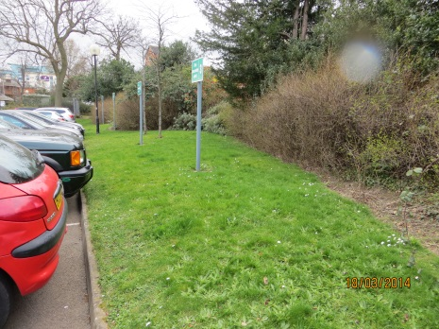
Hedge maintenance | 2 - Amenity | Good quality hedge features forming boundaries and screens in car parks | 1 cut per year | 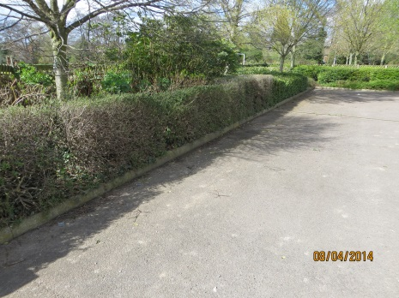
Shrub Maintenance | 2 - Amenity | Amenity shrubberies that add character to car parks and provide additional screening | Winter cultivation, pruning once per year, spot treat weeds up to three times per year | 