Typology 6 – Allotments
Zoned Tasks | Zone | Definition | General Standard | Example
Grass cutting | 3 - General | This standard will be sufficient to ensure access to entry/exit points and to individual plots remain clear | Grass no longer than approx. 100mm, free of unsightly clumps of clippings) | 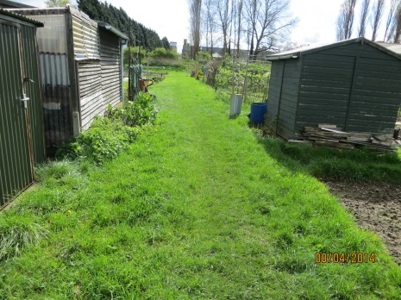
Hedge maintenance | 2 - Amenity | Boundary hedges will be maintained to ensure access paths remain clear throughout the year. Plot holders are responsible for maintaining the face of any perimeter hedge and internal hedges on their own plot. | 1 cut per year during the winter programme | 