Application to use Charnwood Borough Council’s Premises Licence(s) | 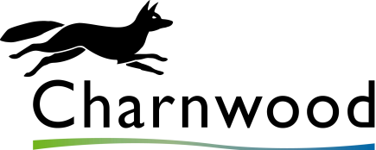

If you are applying to us for permission to use Southfields Park, Queen’s Park or Loughborough Town Centre (including the Market Place) for your event you can also apply to use one, or both, of our Premises Licences for Regulated Entertainment.

Any approval to use our licence(s) will only apply if you are also given our written approval for your event. Please read the relevant licence(s) and the associated mandatory conditions prior to completing this form. These can be found at www.charnwood.gov.uk/premises_licenses. Each licence also gives a list of licensable activities and details of the geographical area covered.

If you are undertaking activities outside the scope of the relevant licence (for example the sale of alcohol), or if your event is taking place elsewhere, you may need to apply for your own licence. Further information can be found at the following web pages:

- www.charnwood.gov.uk/premises_licences_v2
- www.charnwood.gov.uk/temporary_event_notices
- www.charnwood.gov.uk/licensing_information.
Application details

Event name

Organisation applying

Location(s) Southfields Park, Queen’s Park and Loughborough Town Centre (including the Market Place) only

Name(s) of event organiser(s)

Date(s) of event

Start time(s)

Finish time(s)

By submitting this form the event organiser is deemed to be agreeing to the following statement:

I have read, and agree to abide by, the Mandatory Conditions of Use for the licence(s) that I am applying to use. I confirm that the licensable activities mentioned within the licence will take place wholly within the area covered by the licence(s).

Any event approval documentation will require the event organiser to formally sign a statement to this effect.

The completed form should be sent to neighbourhoods.communities@charnwood.gov.uk Please contact us on this email address or on 01509 634710 if you have any queries.

