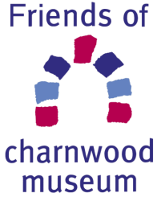

The Friends of Charnwood Museum aim to promote, support, assist and improve Charnwood Museum. Fundraising activities contribute to the purchase of items for the museum collection and exhibitions, and enable provision of a programme of children’s activities and workshops.
The Friends also organise a programme of talks throughout the year and membership allows entry at a reduced cost.
Annual membership subscriptions are:
- £7 (£5 concessions) for Individual membership
- £12 (£9 concessions) for Household membership (2 or more individuals at one address)
(Concessions apply to over 65 years, disabled and job seekers)

Membership form
If you would like to become a Friend of Charnwood Museum, please fill in the form and return it to:
The Membership Secretary, 135 Ashby Road Loughborough LE11 3AB
Please make cheques payable to: ‘Friends of Charnwood Museum’
Name(s):
Email address:
Postal address: (if information is required by post)

Telephone number: Mobile:
Date:

How may we contact you? *
I am happy to receive information from the Friends of Charnwood Museum about Friends events and other matters relating to the museum and other local organisations that may be of interest by the methods indicated:

Please tick: Email Telephone

Post SMS

Amount enclosed ……………………..

Data Protection Statement
Personal data supplied on this form will be held securely and confidentially on computer.
Our Privacy Policy is available on request.
*We won’t contact you without your express consent

