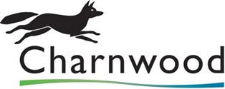

Modern Slavery Act 2015: Requirements under Modern Slavery Act 2015

Question X: Has your organisation, its directors or any other person who has the power of representation, decision or control of the named organisation ever been convicted of slavery, servitude, forced or compulsory labour, child labour or an offence in human trafficking and other forms of trafficking in human beings within the last five years Yes/No

Bidders who answer ‘Yes’ to question X will automatically fail the tendering process

Question X : In accordance with the Modern Slavery Act 2015 all organisations carrying out business within the UK, with a total annual turnover of £36m or more are required to produce a slavery and human trafficking statement for each financial year.

Please confirm if your organisation has an annual turnover of £36m or more Yes/No

If you answered yes to the above question please confirm that you are compliant with the annual reporting requirements contained within Section 54 of the Act 2015? Yes/No

Bidders who answer ‘No’ to question X and who have an annual turnover of over £36m or more will automatically fail the tendering process. Bidders who answer yes to question X will be asked to provide evidence of the annual report upon award of contract.

