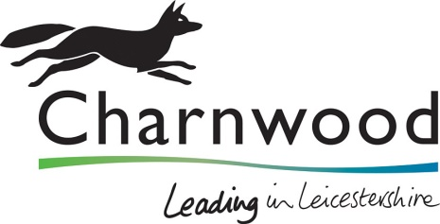

Question X
Do you have a Safeguarding policy?

Yes have safeguarding policy
No but will comply with CBC’s safeguarding policies pending development of your own safeguarding policy and procedures prior to award
No have not got a safeguarding policy and will not comply with the Council's policy

Bidders who answer ‘Yes’ to having a Safeguarding Policy will only receive a Pass if a copy of the policy is provided – label as X
Bidders who answer ‘No but will comply with CBC’s safeguarding policies prior to award’ please provide a method statement that details your proposed methodology to ensure compliance with, and the promotion of the principles contained in the CBC Safeguarding Policies and Procedures as well as the development of your own safeguarding policy– label as X

Please refer to the below link for CBC’s safeguarding policies:-
https://www.charnwood.gov.uk/pages/safeguarding_children_and_young_people
Bidders who answer ‘No have not got a policy and will not comply with the council’s policy’ will fail the tendering process.

Question X
Please provide details of how your organisation meets with its safeguarding responsibilities, please ensure that the following areas are covered within your response:-
- How your organisation complies with relevant safeguarding legislation
- Staff awareness of responsibilities to report concerns through supervision/training/induction materials.
- Your organisation procedural checks for staff who are engaged in works where there are safeguarding considerations
- Your organisation’s identified individual to whom safeguarding concerns may reported.
- Your organisations complaints and disciplinary procedures to manage concerns about staff behaviour.

Response to be no more than (X) sides of A4 font size Arial 12, please label your response as X

