Typology 3 – Amenity Green Spaces

Zoned Tasks | Zone | Definition | General Standard | Example
Grass cutting | 3 - General | This standard of maintenance ensures we can provide useable and attractive recreational areas for residents | Grass no longer than approx. 100mm, free of unsightly clumps of clippings. | 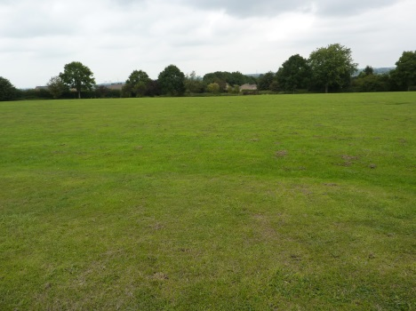
Hedge maintenance | 2 – Amenity | Good quality hedge features that form boundaries in the majority of amenity open spaces | 1 cut per year during the winter programme | 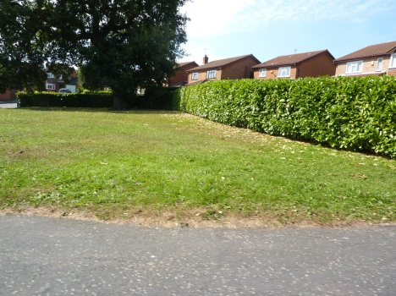
 | 3 – Field | Field hedges bordering amenity green spaces and rural areas, often located on the urban fringe | 1 cut per year during the winter programme | 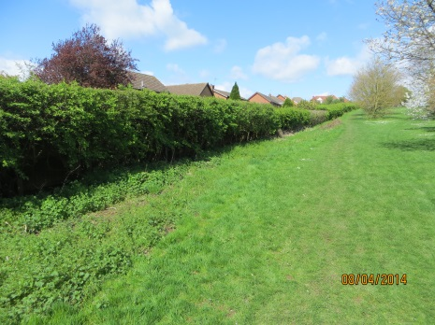
Shrub maintenance | 2 - Amenity | This maintenance regime ensures shrub beds are kept tidy and add character to the area | Pruning once per year, spot treat weeds up to three times per year | 