Typology 4 – Outdoor Sports Provision

Zoned Tasks | Task | Example
Bowling Greens | Bowling greens require a significant range of tasks to be undertaken on a regular basis to uphold standards. These tasks include cylinder mowing, aeration using a range of solid, hollow, slit and sarrel tines; top dressing; over seeding; fertilising; rolling; scarification; verticutting; dragbrushing; irrigation; and the application of fungicides, worm killers, moss killers, insecticides and  wetting agents. | 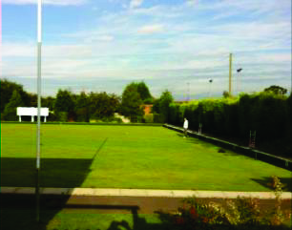
Cricket Pitches | Outfields will generally require regular mowing, aeration and marking out. The maintenance regime required to uphold standards on cricket squares is more comprehensive and includes: cylinder mowing; marking out; selective herbicide and fertiliser application; scarification; solid tining; top dressing; irrigation; rolling; over seeding;  renovation works; and the application of  fungicides, worm killers and moss killers. | 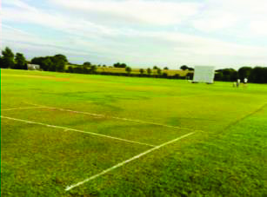
Football & Rugby Pitches | The maintenance of football and rugby pitches is significantly less complex than that of cricket squares and bowling greens. Regular tasks will include grass cutting; aeration using slit tines; marking out; application of fertiliser; application of herbicide; overseeding; and the forking and sanding of goal mouths. | 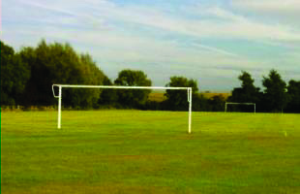
Tennis Courts | Tasks associated with the maintenance of artificial tennis courts will include marking out, regular sweeping and the application of weed and moss killer whenever required. | 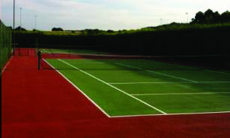
Golf Courses | Tasks associated with the maintenance of the greens will include cylinder mowing; aeration using a range of slit, solid and hollow tines; rolling; vertidraining; topdressing and overseeding; scarification; verticutting; application of herbicide, fungicide and moss killer; and Irrigation. Tasks required to maintain areas of fairway in between greens will include mowing; slit tining; vertidraining;  Scarification and fertilising. | 